G.V.Sai Kiran
18114026

problem statement-1

Write a program transpose.c that takes n, a, b, inputfile.txt in argv[1], argv[2], argv[3], and argv[4], respectively, applies the above encryption; and writes the result to outputfile.txt. Further, write a program inverseTranspose.c that decrypt the outputfile.txt and result in a new file named decryptedOutputfile.txt. Finally, write a program compareFiles.c to find the equivalence between the inputfile.txt and decryptedOutputfile.txt files. You may assume that n, a, and b are all small enough to fit into variables of type int. Your program should exit with a nonzero exit code if n is not at least 1 or if it is not given exactly four arguments, but you do not need to do anything to test for badly-formatted arguments. You should not make any other assumptions about the values of n, a, or b; for example, either of a or b could be zero or negative.
Transpose.c
start
declare variables s,n,a,b,count,ch,str
read the file
print the file
declare lol,req,rl,l
if(l is divisible by n)
rl=l
else
rl=smallest multiple of n greater than l
create a new array with length rl
initialize elements from l to rl =0
create a matrix with size rl/n*n
shuffle each row using this condition j=((a*i)+b)%n;
store this in new array
store this array in outputfile.
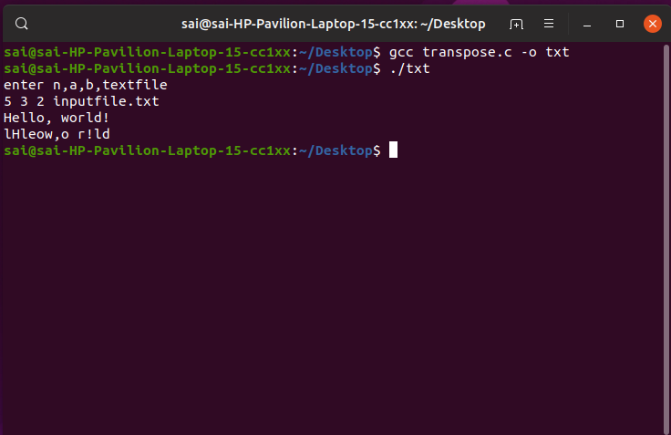

Inversetranspose.c
start
declare variables s,n,a,b,count,ch,str,a’,b’
read the file
print the file
declare lol,req,rl,l
if(l is divisible by n)
rl=l
else
rl=smallest multiple of n greater than l
create a new array with length rl
initialize elements from l to rl =0
create a matrix with size rl/n*n
a1=(h*n+1)%a,b1=n-((a1*b)%n)
shuffle each row using this condition j=((a’*i)+b’)%n;
store this in new array
store this array in outputfile.
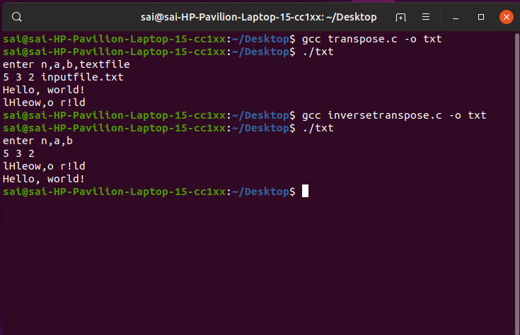

Compare.c
start
read both the files
check if they are same
if(true)
print both are same
else
print both are different.
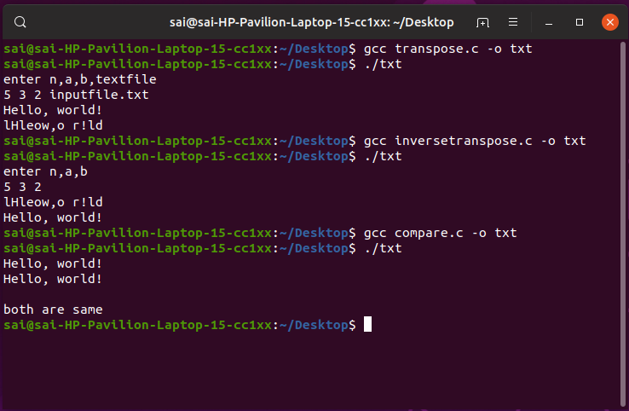

Problem statement-2
Write a C program, MAT.c to represent any region (in image array representation), into its quadtree form.
Start
declare count,count2,depth
function to check if all the elements are same or not
a recurrsive function to split the array if all elements are not equal
a recurrsive function to find the depth
declare symbols,columns,rows
read the file
store the array
find power of n greater or equal to given size
initiate split
initiate depth_function
